

Rapport de stage

Second Year of the second Cycle (2CS)

Option: Systèmes Informatiques (SQ)

Topic:
Design and Deployment of SSO Solution
(Single Sign On)

Done by: Supervised by:
-Bentitraoui Abderrahmane -Mr Neffah Mohamed
-Lehanine Ahmed -Mr Souker Seif-eddine

Host organisation :
Sonatrach Hydra Algeries

Abstract#:
Delivering applications quickly and reliably requires automation of both the infrastructure and the deployment process. Most solutions for this rely on public cloud services, which is not acceptable when data must remain on the local network and recurring costs must be avoided. This internship, carried out at [host organization], aimed to design and implement a fully self-hosted platform that automates infrastructure provisioning, continuous integration and delivery, and self-healing, with no dependency on any external cloud service.
After a study of existing solutions, which eliminated cloud-based offerings and compared the self-hosted ones, two variants of the platform were built on a Proxmox VE hypervisor. Both create a k3s Kubernetes cluster with Terraform and deploy applications with a pull-based GitOps model. The first variant uses GitLab and ArgoCD. The second uses Gitea and FluxCD, with MinIO as the Terraform state backend and Ansible to repair failed worker nodes in place before resorting to recreating them. Three workflows were implemented: infrastructure automation with scheduled health checks, CI/CD with automatic manifest updates, and promotion of an image from staging to production. The platform was documented so that it can be redeployed from scratch, and a procedure was defined for adding new applications.

Table of contents
Abstract: I
Table of contents II
Table of figures IV
List of tables IV
List of Abbreviations IV
Chapitre 1 : General introduction 1
1.1 Introduction 1
1.2 Context and Objectives of the Internship 1
1.3 Problem Statement 1
Chapitre 2 : Host organisation 2
2.1 Information Systems at Sonatrach: 2
2.2 Localisation of host organisation : 2
Chapitre 3 : Study of the existent: 3
3.1 Introduction : 3
3.2 Elimination of solutions relying on cloud : 3
3.3 Comparison of the compliant solutions : 4
3.4 Conclusion : 5
Chapitre 3: Technologies and Architectural Choices 6
3.1 Introduction: 6
3.2 Technologies 6
3.2.1 Docker and containerization: 6
3.2.2 Keyclock 7
3.2.3 Patroni: 7
3.2.4 Etcd 7
3.2.5 HA-Proxy 9
3.3 Architecture 9
3.3.1 Overview 9
3.3.2 Accssess layer 10
3.3.3 Identity layer: 10
3.3.4 Database accesses layer: 10
3.3.5 .Database layer: 10
3.4 Login Flow: 11
Chapitre 4 : Mise en œuvre de la solution 13
1.Introduction : 13
2. Phase 1 : testing and configuring 13
2.1. Setting up the etcd cluster (db1, db2 and keycloak1): 13
configuration: 13
2.2. Setting up Patroni and postgreSQL (db1, db2): 13
configuration: 13
2.3. Setting up HAproxy (db1, db2): 14
configuration: 14
2.4. Setting up keycloak (keycloak1, keycloak2): 14
3.Phase 2 : deploying in production 14
3.1. Offline Production Environment: 14
3.2.Network Security and Isolation 15
3.3.Service-to-Service Authentication 15
3.3.1. etcd Authentication (Patroni's communication with etcd) 15
3.3.2.Patroni REST API Authentication (HAProxy's health checks) 16
3.5.Keycloak Realm Configuration 16
3.5.1. User Federation: 16
configuration: 16
3.5.2. Clients: 17
3.5.3. Groups: 17
3.5.4. Roles: 17
3.5.5. Admin Users: 17
Phase 3 : Exploitation & validation: 17
Authentication Testing with Federated Users 18
Availability Testing 18
Adding Open WebUI as a Client 18
Keycloak-side configuration 18
Client-side configuration 18
Conclusion: 19

Table of figures
Figure 1 Location of host organisation 5
Figure 2 Docker container build and deployment workflow. 10
Figure 3 Three-node etcd cluster 12
Figure 4 layer based architecture 13
Figure 5 Login flow diagram 15
Figure 6 Flow matrix 19

List of tables
Table 1 Solutions eliminated because they rely on cloud-hosted services 6
Table 2 Comparison of compliant SSO solutions. 7
Table 3 Advantages and disadvantages of the compliant SSO solutions 8

List of Abbreviations
Abbreviation | Meaning
AD | Active Directory
API | Application Programming Interface
DB | Database
HA | High Availability
IAM | Identity and Access Management
JDBC | Java Database Connectivity
LDAP | Lightweight Directory Access Protocol
OIDC | OpenID Connect
OU | Organizational Unit
SSO | Single Sign-On
VM | Virtual Machine

Chapitre 1 : General introduction !

Introduction
Everyone knows about software development, but what most see as inconsequential, is how said software is being deployed, hosted and maintained, that’s software delivery.
The standards of software delivery has entirely changed over the last decade, from a manual process, that all it cares about is just getting the service accessible at that moment, to an expectation of software being available 24/7, easily scalable and convenient to update the deployed software to new versions. For that a manual process no longer can get the task done, especially where a single human error would round it inaccessible. That’s where DevOps kicks in, with two main ideas: Infrastructure as Code (IaC), where the infrastructure is described and created from files, and Continuous Integration / Continuous Delivery (CI/CD), where building, testing, and deploying are automated.
A more recent approach, GitOps, builds on both. A Git repository becomes the single source of truth for what should be running, and an agent continuously reconciles the live state with the wanted state, declared in the git repo.
This report describes the design and implementation of a complete CI/CD and GitOps setup that runs entirely on premise, and promises auto scaling and healing worker vms of a Kubernetes cluster, where apps in the repo are automatically deployed into said cluster.

Context and Objectives of the Internship
This internship was done at, Sonatrach DG in a space for interns called “innovation center”, in which there was no apparent need for such system, but it was an interesting subject that would make the next interns’ life a bit easier.
The goal of the internship was to design, deploy, and document a setup that covers the whole application delivery lifecycle, from creating the infrastructure to running the application in a Kubernetes cluster. The specific objectives were:
- Automate the monitoring, healing and scaling of the infrastructure mainly worker nodes of the kubernetes cluster.
- Set up a CI/CD pipeline that builds the images of an application, stores them, and updates the deployment manifests automatically.
- Add a system that watches the repo and makes sure that the deployed system is in the wanted version.
- Simulate the promotion of an image from a staging environment to a production environment.

Report Structure:

Chapitre 2 : Host organisation !
Sonatrach (Société Nationale pour la Recherche, la Production, le Transport, la Transformation et la Commercialisation des Hydrocarbures) is Algeria's national oil and gas company, established on December 31, 1963. It is the oldest and largest economic enterprise created after the country's independence, and it currently ranks as the leading oil and gas company on the African continent, often referred to as "the African major."

2.1 Information Systems at Sonatrach:
Given the strategic and sensitive nature of its activities, Sonatrach relies almost entirely on internally developed and internally hosted applications to manage its operations, rather than external or cloud-based services. This approach is not only an internal organizational choice but also a legal requirement: Algerian law on the protection of personal data, along with national regulations on cybersecurity, requires sensitive and personal data to be processed and stored within national territory, under the direct control of the organization, rather than foreign cloud providers.

2.2 Localisation of host organisation :
The work presented in this report was carried out within Sonatrach's facility located in Djenane Malik, Hydra, in Algiers, one of the Group's central sites hosting several of its administrative and information systems departments. This location serves as a hub for internal IT operations, making it a suitable environment for the design, testing, and deployment of infrastructure-related projects and different solution.
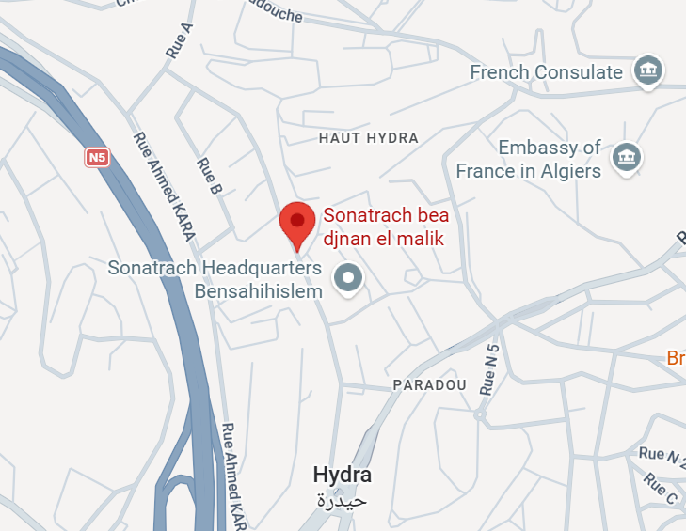
Figure 1 Location of host organisation

Chapitre 3 : Study of the existent!:

3.1 Introduction :
The setup designed in this internship requires the following functions:
- Virtualization: host the virtual machines of the platform.
- Infrastructure provisioning: create and destroy vms from code.
- Infra management: configure the machines and repair them when they fail.
- Container orchestration: run the containerized applications (will be done by Kubernetes, so here we shall compare which Kubernetes distribution would be used).
- Git hosting and CI/CD: store the code and run the build and deployment pipelines.
- GitOps deployment: keep the cluster aligned with the manifests stored in Git.
Note: any cloud dependent solution would not take part in the comparison,

3.2 Comparison of solutions :

3.2.1 Virtualization
There was no comparison here, since proxmox VE was already installed in a server,
so we used that directly. as they say, if it is not broken don’t fix it.

3.2.2 Infrastructure provisioning
Solution | Main features | Remarks
Terraform | • Describes the desired infrastructure in HCL files  • Keeps a state file that records what exists and detects drift  • has provider ecosystem, that includes Proxmox | Works best with cloud init, since the config that terraform can apply is minimal.
OpenTofu | • Practically same features of terraform | A fork of terraform, main advantages being open source, but terraform has a more mature ecosystem.
Pulumi | • Defines the infra using common programing languages (go, python …ect)  • also defines a state file, that saves what was created. | Again, has a way less mature ecosystem, compared to terraform.
Crossplane | • Manages infrastructure as Kubernetes resources  • Continuous reconciliation | Runs inside Kubernetes, so it cant build the k3s cluster, so doesn’t work in our setup.
Ansible modules | • Can create VMs through the Proxmox modules  • Ansible could also configure them | Doesn’t save the state, so managing the created vms will require other systems.

Conclusion:
From the Iac solutions, terraform is the most widely used and using it is the most straight forward in our setup (install terraform in our runner then terraform apply)

3.2.3 Infra management
This part contains all the solutions that would allow us to configure/manage/install things in the created vms.

Solution | Main features | Model | Remarks
cloud-init | • Configures a machine at first boot  • Lets us configure things, such as the network settings, hostname …ect  • Can launch a bash script, which allows us to modify any config files, or other settings | Executed once | Works very well with terraform  Cannot act on a machine that is already running
Chef | • Uses ruby files to define recipes (cookbooks), that specify the desired state and how to get to it, step by step  • Uses a central server to manage and distribute configurations to the machines  • Requires an agent to be installed on the managed machines | Agent-based | Needs an agent on each node and a server, so it can’t be easily integrated in our pipeline.
Puppet | • defines the final desired state, and how it is achieved is behind the scenes  • Uses a central server to manage and distribute configurations to the machines.  • Requires an agent to be installed on the managed machines | Agent-based | Needs an agent on each node and a server, so it can’t be easily integrated in our pipeline.
Ansible | • Configures and manages machines remotely.  • Uses YAML playbooks to define tasks, that have access to info, and certain actions using ansible’s built in commands/fields.  • Can also launch bash scripts inside the jobs. | Agentless, over SSH | Nothing to install on the nodes; suited to checks and repairs
SaltStack | • Can execute commands on multiple machines at the same time  • Supports both agent-based and agentless management  • Can react to events and automatically trigger actions | Agent-based or agentless | Also requires its own service to be hosted, which would complicate things.

Conclusion:
We used cloud init to initialize our vms, since it is very convenient to be able to creat a vm and it would have everything u need installed, without getting a whole other system sat up and involved, which is required for Chef, Puppet and SaltStacks.
As for making sure that what is actually in the vms, matches what we want, we went for linux scripts in the pipeline for setup1, and we used ansible in setup2, both approaches are adequate since they both can easily be executed inside a runner.

3.2.4 Kubernetes distribution:
We could use k8s (Kubernetes) directly, but that would require manually installing and configuring its different components (eg: container runtime, networking, and control plane), which can be simplified by using prebuilt distributions such as k3s, k0s that provide preconfigured components and can be deployed by installing a single service.
Solution | Main features | Remarks
RKE2 | • Kubernetes distribution designed with security in mind  • Supports hardened configurations  • Provides production-oriented cluster management | Offers additional security features, but these introduce unnecessary complexity and resource overhead for our setup.
MicroK8s | • Installed through Snap  • Add-ons can be enabled with simple commands  • Supports clustering across multiple nodes | Supports automated installation, but its reliance on Snap makes it less convenient for our cloud-init-based deployment.  Joining nodes requires additional configuration compared to the other distributions
k3s | • Certified Kubernetes distribution packaged as a single binary  • Includes an ingress controller and basic storage components  • Workers join using a simple token | Works well with cloud-init, since a worker can be configured and joined to the cluster automatically using a token and a short installation script.  It has low resource consumption.
k0s | • Single-binary Kubernetes distribution  • Minimal dependencies  • Separates control-plane and worker processes | Offers a lightweight alternative to k3s, but its advantages are limited in our setup. since k3s provides usefule features such as worker joining the cluster through join token.
kubeadm | • Official Kubernetes cluster bootstrapping tool  • Provides control over cluster components  • Supports standard Kubernetes configurations | Provides greater control over cluster initialization, but requires additional steps to configure. This makes automated deployment more complex.

Conclusion:
We went for k3s, since we are doing auto deployment of the workers, so the more complex distros such as RKE2 would make it way more difficulte, and k3s has a very straight forward installation/cluster joining process, (from 1 short script) which can be easily done through cloud-init.

3.2.5 Git hosting and CI/CD
Git hosting and ci/cd functionalities are not necessarily in the same solution, for example there are populare solution like Jenkins, Tekton that don’t provide git hosting, but for the sake of the simplicity of the setup, we went for solutions that provide both git hosting and ci/cd.
Solution | Main features | Remarks
GitLab | • Git hosting and integrated CI/CD  • Container and package registries  • Terraform state backend  • Pipelines defined in .gitlab-ci.yml | Provides most required services in one platform, reducing additional dependencies. but its resource consumption is relatively high.
Forgejo | • Git hosting and Forgejo Actions  • Container and package registries  • YAML-based workflows | Based on gitea, but with smaller community and ecosystem.
Gitea | • Git hosting and Gitea Actions  • Container and package registries  • Workflows defined in .gitea/workflows/ | Lightweight and easy to deploy on-premises. Requires an external Terraform state backend such as MinIO.
OneDev | • Git hosting and built-in CI/CD  • Container and package registries  • Integrated issue tracking | Has a smaller ecosystem and less widespread adoption

Conclusion:
We went for Gitlab and Gitea, we used Gitlab in setup 1 and it was pretty resource intensive. So we used gitea in setup two, and it was lighter, but way more tiresome to use, for example in gitlab runner we only needed to list the packages we needed and it works out, but in gitea u need to manually install the needed software, and worry about their compatibility with the used linux image.

3.2.6 GitOps deployment:
Solution | Main features | Remarks
ArgoCD | • Adds custom kubernetes object such as application which link a repository path to a namespace  • Provides a resource tree, and history and rollback for each service  • Has a web interface, which makes it easier to monitor the running services and make changes. | Is a solution hosted as a namespace in the Kubernetes cluster, and what sets it apart from the other solutions is its web interface, which makes it way easier to get into.
Jenkins | • Provides a CI/CD platform built around Kubernetes.  • Automates application builds, testing, and promotion between environments. | Currently, we are going for ci/cd managed by git lab/gitea, so what Jenkins offer is beyond our current needs.
FluxCD | • Supports Helm and Kustomize for managing Kubernetes manifests.  • Automatically reconciles the cluster state with the configuration stored in Git.  • Provides configurable GitOps reconciliation and control over deployment dependencies. | Lighter than Argo CD and capable of performing the same core GitOps functions, but it has no visual interface, so everything is through the cli, but there exist other solutions that can provide a visual interface for it.
Rancher Fleet | • Provides deployment management across multiple Kubernetes clusters.  • Uses Git repositories and bundles to distribute configurations.  • Supports centralized deployment status and management of cluster groups. | Designed primarily for managing deployments across large number of clusters, and such capabilities are unnecessary for our setup

Conclusion:
Our first choice was argocd, since it is the most user friendly and provides the functionalities that we need, but we also used fluxcd seeing how it provides practically the same functionalities, So in setup1 and setup2 we used argocd and fluxcd respectively.

3.3 Choices summary:
Function | Setup1 | Setup2
Virtualization | Proxmox VE | Proxmox VE
Infrastructure provisioning | Terraform | Terraform
Infra management | Bash scripts inside pipeline | Bash scripts + ansible playbooks inside pipeline
Container orchestration | K3s | K3s
Git hosting and CI/CD | GitLab | GitTea
GitOps deployment | ArgoCD | FluxCD

Chapitre 4: Technologies and workflows !

4.1 Introduction
This chapter presents the workflows that we seek to automate, and the used technologies and the architecture of our two setups that differ in the Git platform, the GitOps controller, and the way the infrastructure monitoring and healing is handled, but share the infra creation components (terraform, proxmox and k3s).

4.2 Workflows

4.2.1 Infrastructure automation workflow
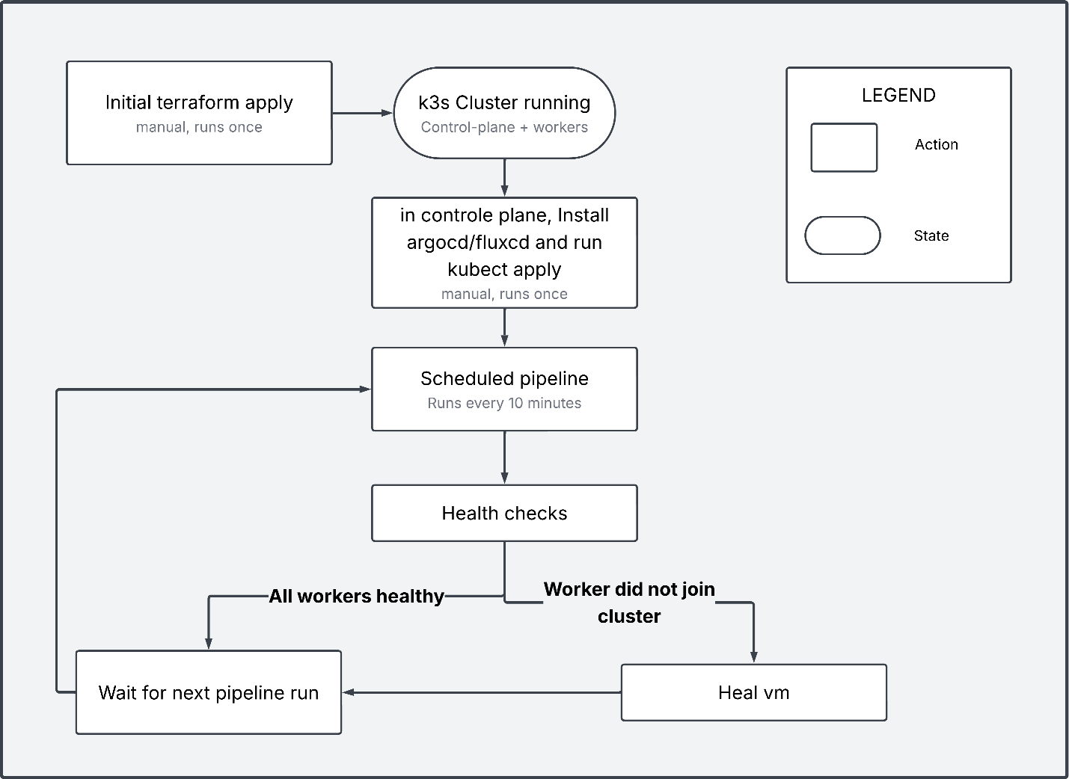
Figure 1 Infra automation workflow diagram
The initial creation is not automated, since trying to automate the creation and management of the control plane of a Kubernetes instance would most likely do more harm than good, so manually creating it is what we went for.
Now to the automated part, this setup runs a pipeline inside gitlab/github which check the health of the nodes along other things, and if there are issues (eg; worker did not join the k3s cluster), in setup 1 the problematic vm would be destroyed and recreated using terraform commands, meanwhile in setup 2 it would try to heal it using ansible playbooks, and if it fails it would do as setup 1.

4.4.2 CI/CD workflow:
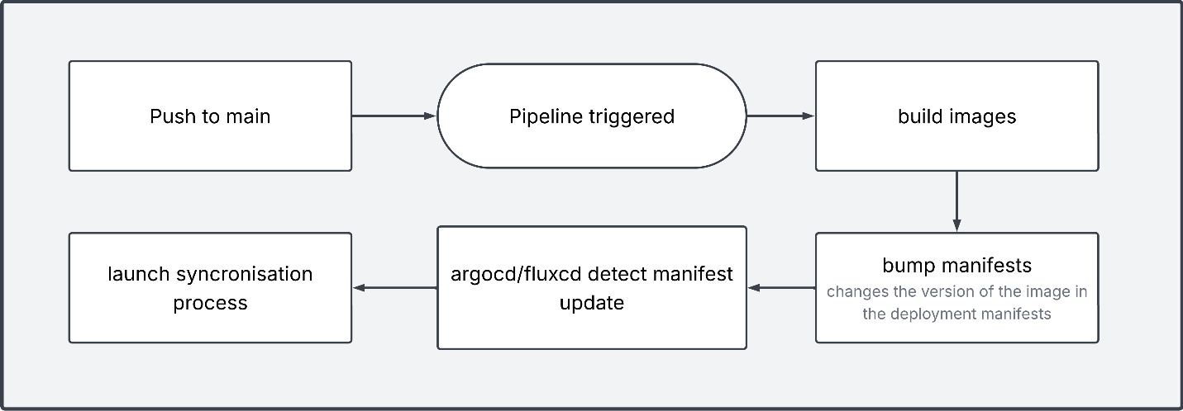
Figure 2: CI/CD workflow diagram
The ci/cd has two main models (push model and pull model),
The push model is where once there is a change in the repo, the ci/cd pipeline applies said changes to the cluster, and the pull model (what we used) is where the cluster (through fluxcd/argocd) monitors the repo and once it detected changes it marks the current build as asynchronous, pulls the changes from the repo and tries to synchronize it.
Note: currently the pipeline trigger is any push to the main branch, this should be changed to what suits the dev team.

4.4.3 Image promotion workflow
The setup simulates the passage from staging to production by promoting an image from one namespace to another.
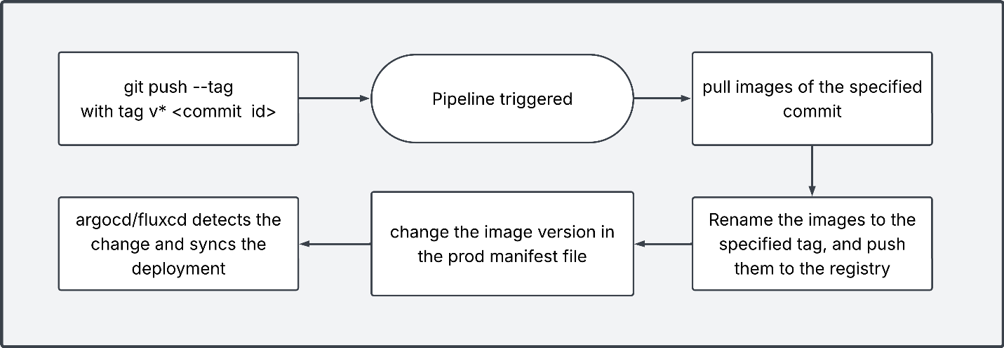
Figure 3: Image promotion workflow
When we push a commit image with the tag (v* commit-id), it would trigger the pipeline, and specifically the promotion job, which would pull the images that correspond to the commit-id, and rename them with the specified tag, then it would repush them in the container registry and update the manifests of the prod namespace, so the newly promoted image would be the one used there).

4.3 Technologies

4.3.1 Proxmox VE
Roles:
- Hosts and manages the vms required by the platform.
- Provides the virtualization resources, including CPU, memory, storage, and network interfaces, allocated to each virtual machine.
- Provides an API used by Terraform to create, configure, and destroy virtual machines.
Notes:
- The virtual machines are created from a preprepared Ubuntu template.
- Access to the Proxmox API is authenticated using a token composed of a token ID and a secret.

4.3.2 Terraform:
Roles:
- From a prepared template (a vm created form image jammy-server-cloudimg-amd64.img), we use terraform to create the vms of the k3s cluster, and we configure said vms using cloud init file.
- Is invoked in two distinct contexts: a one-time manual initial apply to bootstrap the cluster, and repeated applies triggered by the scheduled monitoring pipeline (worker healing, scale up/down)
Notes:
- whenever u (terraform apply) you create a state file, that file is needed for any further terraform commands on the created vms, so it must be available.
that availability is provided by gitlab (setup1) and minio (setup2)

4.3.3 Kubernetes:
We used k3s (a lighter distribution), is the container orchestration layer

4.3.4 Argocd/fluxcd:
Roles:
- It is what deploys/manages the apps that we want to deploy inside the cluster.
- It monitors the manifests repo of the deployed apps, and once it detects changes it reconciles with the deployed version and synchronise it.
Notes:
- Adding an app is a manual process, of cloning the manifest repo and applying (kubectl apply -f path) the aregocd/fluxcd directory.

4.3.5 Gitlab (setup 1):
Roles:
- Is a git hosting platform, that contains our repos
- Provides a container registry where our built images are saved
- Provides Terraform state backend, that makes the state file accessible
- GitLab pipelines are used for infrastructure monitoring and self-healing, as well as CI/CD.

Notes:
- The ci/cd pipeline need to be added for each app (not a single general one)
- Gitlab requires at least one runner (a different software ran as a container and registered into gitlab), and said runner is what execute the pipelines and other jobs.

4.3.6 Gitea (setup 2):
Roles:
- Is a git hosting platform, that contains our repos
- Provides a container registry where our built images are saved
- GitLab pipelines are used for infrastructure monitoring and self-healing, as well as CI/CD.

Notes:
- The ci/cd pipeline need to be added for each app (not a single general one)

4.3.7 Minio (setup 2):
Minio is an s3 solution, used here solely as the state backend for terraform

4.3.8 Ansible (setup 2):
Currently in setup 1, if a worker failed to join the cluster the whole worker vm is destroyed, and recreated, which is awfully inefficient.
So, in setup2 we used ansible in the infra pipeline to manage the service (k3s agent) and runs the tests (internet access, disk space, k3s agent state …ect), so if the worker failed to join the cluster ansible will first try to fix the k3s agent, and if it fails, we simply destroy and recreate the vm, which a way more efficient approach.

Chapter 4: Solution Deployment and Integration#
5.1 Introduction
This chapter describes how the two variants of the platform were deployed on the local network of [host organization]. Each setup is presented in the same way: first the virtual machines and the network flows between them, then the deployment guide in numbered steps. The guide is written so that the whole platform can be rebuilt from scratch. The final section explains how a new application is added to a running platform.
In the commands below, values between angle brackets (for example <gitlab ip>) must be replaced with the values of the target environment, and ./ refers to the root of the folder of the setup being deployed (cicd setup1 or cicd setup2).
5.2 Setup 1 — Terraform / GitLab / ArgoCD
5.2.1 Virtual machines and network flow matrix
VM | Role | IP address | Containers
cicd1-gitlab | Git platform, registry, Terraform state, CI/CD | 192.168.10.173 | GitLab, GitLab Runner
k3s-controle-plane | Kubernetes control plane, ArgoCD | 192.168.10.177 | none
k3s-worker-* | Kubernetes workers | DHCP | none
The main network flows that follow from the design are summarized below. Ports are the usual defaults of each tool; the full matrix is in the separate Excel file, which should be reconciled with this table.
Source | Destination | Purpose | Port (default)
Admin machine (Terraform) | Proxmox API | Create and destroy VMs | 8006/TCP
Admin machine, runner | GitLab | Git, registry, Terraform state over HTTP | 80/TCP
GitLab Runner (CI jobs) | Proxmox API, k3s VMs | Scheduled infra pipeline: Terraform and SSH | 8006/TCP, 22/TCP
ArgoCD (control plane) | GitLab | Pull the manifests repository | 80/TCP
k3s nodes | GitLab registry | Pull application images | registry port
Workers | Control plane | Join and communicate with the cluster | 6443/TCP
Administrator | k3s VMs | SSH administration | 22/TCP
5.2.2 Deployment guide
Step 1 — Preparations. Create the virtual machine cicd1-gitlab with any Linux server operating system.
Step 2 — GitLab.
- Copy the ./gitlab-setup/ folder to the cicd1-gitlab VM and start GitLab:
sudo docker compose up
- Retrieve the initial password of the root account:
sudo docker exec -it gitlab grep 'Password:' /etc/gitlab/initial_root_password
- Log in as root with that password and change it.
- Create a group, then three projects inside it: app, infra, and manifests.
- Push the three local repositories into these projects.
Step 3 — Register the runner.
- In the group, go to Settings → CI/CD → Runners and create a new runner. Copy the token, which starts with glrt-.
- Register the runner from its container:
docker exec -it "<GitLab Runner container name>" gitlab-runner register \
--url "<GitLab url>" \
--token "<RUNNER_TOKEN>" \
--executor "docker" \
--docker-image "docker:24" \
--docker-volumes "/var/run/docker.sock:/var/run/docker.sock"
The Docker socket is mounted so that jobs can build container images. The runner must appear as Idle on the page where the token was created.
Step 4 — Create the initial k3s cluster with Terraform.
- In ./repos/infra/terraform.tfvars, check the Proxmox URL, token ID, and token secret. Replace the public SSH key if its private key is not available.
- In ./repos/infra/cloud-init/, check the registry URLs (they define the insecure registries).
- In GitLab, create an access token for Terraform (profile → Access Tokens) with the api scope.
- On a machine that has Terraform installed and can reach the Proxmox URL, configure the HTTP backend and apply:
cd ./infra/
export TF_HTTP_ADDRESS="http://<gitlab ip>/api/v4/projects/2/terraform/state/default"
export TF_HTTP_LOCK_ADDRESS="$TF_HTTP_ADDRESS/lock"
export TF_HTTP_UNLOCK_ADDRESS="$TF_HTTP_ADDRESS/lock"
export TF_HTTP_USERNAME="root"
export TF_HTTP_PASSWORD="<TOKEN HERE>"
export TF_HTTP_LOCK_METHOD="POST"
export TF_HTTP_UNLOCK_METHOD="DELETE"
terraform init
terraform apply
The number 2 in the address is the ID of the infra project in GitLab. Any script that must run right after the machines are created (for example, a network configuration) can be added to the cloud-init file.
- Connect to the control-plane VM over SSH using the private key matching the public key in terraform.tfvars, then run kubectl get nodes. The cluster is ready when all workers are in the Ready state.
Step 5 — ArgoCD. On the control-plane VM:
kubectl create namespace argocd
kubectl apply -n argocd -f https://raw.githubusercontent.com/argoproj/argo-cd/stable/manifests/install.yaml
kubectl get pods -n argocd
git clone http://<gitlab ip>/<organisation>/manifests.git
cd manifests/
kubectl apply -f ./argocd/
The last command creates the secrets and the Application objects in the argocd namespace. The installation manifest is downloaded from the internet, so the control plane needs temporary internet access for this step; in a fully isolated network, the file would have to be downloaded beforehand and applied locally. The state of the applications can be followed in the ArgoCD web interface, whose port is obtained with kubectl get svc -n argocd (the argocd-server service).
Figure 5.1 — ArgoCD applications view: the headlamp, prod, and staging applications, all Healthy and Synced.
Figure 5.2 — ArgoCD resource tree of the staging application: namespace, persistent volume claim, services, deployments, pods, and the horizontal pod autoscaler of the backend.
Step 6 — Infrastructure monitoring and healing pipeline. In the infra project, go to Settings → CI/CD → Variables and add SSH_PRIVATE_KEY (the private key of the cluster VMs), PROXMOX_API_TOKEN, PVE_TOKEN_SECRET, and PROXMOX_URL. Then create a pipeline schedule so that the monitoring pipeline runs periodically.
5.3 Setup 2 — Terraform / Ansible / Gitea / FluxCD / MinIO
5.3.1 Virtual machines and network flow matrix
VM | Role | IP address | Containers
cicd2-gitea | Git platform, registry, CI/CD | 192.168.10.173 | Gitea, Gitea Runner
cicd2-k3s-controle-plane | Kubernetes control plane, FluxCD | 192.168.10.177 | none
cicd2-k3s-worker-* | Kubernetes workers | DHCP | none
cicd2-minio | Terraform state backend | 192.168.10.89 | MinIO
The flows are the same as in Setup 1, with three differences: Gitea listens on port 3000/TCP, Terraform reads and writes its state on MinIO instead of GitLab (the console is on 9001/TCP; the S3 API port is the MinIO default, 9000/TCP, to confirm in the compose file), and the monitoring pipeline also connects over SSH to the workers to run the Ansible checks. The complete matrix is in the separate Excel file.
5.3.2 Deployment guide
Step 1 — Preparations. Create the virtual machines cicd2-minio and cicd2-gitea.
Step 2 — MinIO.
- Copy the ./minio/ folder to the cicd2-minio VM and start the service:
cd ./minio/
sudo docker compose up
- Open http://<MinIO-VM-IP>:9001 and log in with the administrator account defined in docker-compose.yml.
- Create a bucket named terraform-state, then create an access key for it.
- Put the access key and secret key in the backend block of ./repos/infra/main.tf.
Step 3 — Gitea.
- Copy the ./gitea-setup/ folder to the cicd2-gitea VM and start Gitea:
cd ./gitea-setup/gitea/
sudo docker compose up
- Open http://<gitea ip>:3000, create an organization, and create the three repositories (app, infra, manifests).
- In the organization, go to Settings → Actions → Runners and create a new runner. Paste the registration token in the Docker Compose file of the runner, then start it:
cd ./gitea-setup/gitea-runner/
sudo docker compose up
- Check that the runner is shown as Idle, then push the three local repositories into the organization.
Step 4 — Create the initial k3s cluster with Terraform. The checks on terraform.tfvars, the cloud-init files, and the SSH key are the same as in Setup 1. No backend variables are needed, since the backend is configured in main.tf.
cd ./infra/
terraform init
terraform apply
As before, the cluster is validated by running kubectl get nodes on the control plane and checking that all workers are Ready.
Step 5 — FluxCD. On the control-plane VM:
export KUBECONFIG=/etc/rancher/k3s/k3s.yaml
curl -s https://fluxcd.io/install.sh | sudo bash
flux check --pre
flux install
kubectl get pods -n flux-system
git clone http://<gitea ip>:3000/<organisation>/manifests.git
cd manifests/
kubectl apply -f ./flux/
KUBECONFIG must be exported in every SSH session in which the flux command is used. The last command creates the secrets and the Kustomization objects, which tell FluxCD which repository and path to monitor and deploy automatically. FluxCD has no user interface: the state of an application is read with kubectl get pods -n <app namespace>, and the events of a failing pod with kubectl describe pod <pod name> -n <app namespace>.
Step 6 — Infrastructure monitoring and healing pipeline. In the infra repository, go to Settings → Actions → Secrets and add SSH_PRIVATE_KEY, K3S_TOKEN, MINIO_ACCESS_KEY, MINIO_SECRET_KEY, and PROXMOX_API_TOKEN.
5.4 Adding a New Application to the Platform
Adding an application to either setup requires three things: a repository for the project, a CI/CD pipeline, and Kubernetes manifests.
5.4.1 Repository. Create a new repository in GitLab or Gitea and upload the project.
5.4.2 CI/CD pipeline. The pipeline is defined by a file in the repository of the application, and the file depends on the setup:
 | Setup 1 (GitLab) | Setup 2 (Gitea)
Pipeline file | .gitlab-ci.yml | .gitea/workflows/<name>.yml (each YAML file in this folder is a pipeline)
The main job of the pipeline is to build the images of the project (for a three-tier website, one for the backend and one for the frontend) and to change the manifests so that they point to the new images. The jobs of the provided web application can be used as a starting point and modified. Other jobs, such as tests run before pushing a new image, can be added. By default, the pipeline runs on every push to the main branch; this should be adjusted to the workflow of the team.
5.4.3 Manifests. The manifests repository is what ArgoCD or FluxCD watches. Whatever Kubernetes YAML sits in the path pointed to by the Application or Kustomization object is deployed automatically when it changes. Two things are therefore created in the repository:
 | Setup 1 (ArgoCD) | Setup 2 (FluxCD)
Object that declares the application | Application file in the argocd folder | Kustomization file in the flux folder
Deployment manifests | A folder referenced by that object | A folder referenced by that object
The existing staging/ and prod/ folders serve as models for the structure. Finally, since adding an application is a manual operation done once, the manifests repository is pulled on the control plane and the matching folder is applied again:
kubectl apply -f ./argocd/ # Setup 1
kubectl apply -f ./flux/ # Setup 2
From that point, every change pushed to the repository of the application triggers the cycle described in Chapter 4: build, manifest update, detection by the GitOps controller, and synchronization.
5.5 Conclusion
Both setups can be deployed from scratch following the six steps above. They differ mainly in Step 2 (GitLab or MinIO as state backend), Step 3 (the Git platform and its runner), Step 5 (ArgoCD or FluxCD), and in the secrets required by the infrastructure pipeline. The next chapter checks that the deployed platform behaves as designed.

Chapter 5: EXPLOITATION AND VALIDATION#
6.1 Introduction
This chapter verifies that the deployed platform behaves as designed. Each test follows the same format: objective, procedure, expected result, and observed result. The tests follow the three workflows of Chapter 4: CI/CD and image promotion (6.2), GitOps synchronization (6.3), and infrastructure monitoring and healing (6.4). Section 6.5 reports the problems met during the implementation. Unless stated otherwise, each test was run on both setups.
6.2 Testing the CI/CD Pipeline
Test T1 — Build and manifest update
- Objective: check that a push to the main branch of the app repository builds the images and updates the manifests.
- Procedure: push a small change (for example, a modified text in the frontend) to the main branch. Follow the pipeline in GitLab or Gitea.
- Expected result: the pipeline is triggered automatically. The runner builds the backend and frontend images, pushes them to the registry, and commits the new image version in the staging manifests.
- Observed result: [pipeline duration, jobs status, new image tag, screenshot of the pipeline].
Test T2 — Image promotion to production
- Objective: check that an image already built can be promoted to production without rebuilding it.
- Procedure: push a tag starting with v on a given commit (git tag v1.0.0 <commit id>, then git push --tags).
- Expected result: the tag triggers a pipeline that pulls the images of that commit, retags them with the specified version, pushes them to the registry, and changes the image version in the production manifest.
- Observed result: [tag used, resulting image tag in the registry, change in the prod manifest, screenshot].
Test T3 — Runner availability
- Objective: check that the runner registered during the deployment is available.
- Expected result: the runner is shown as Idle when no job is running, and as Running during a job.
- Observed result: [screenshot].
6.3 Testing GitOps Synchronization
Test T4 — Automatic synchronization after a manifest change
- Objective: check that ArgoCD or FluxCD applies a change made in the manifests repository without any manual action on the cluster.
- Procedure: change the image version (or the number of replicas) in the staging manifest, push it, and observe the cluster.
- Expected result: the controller detects the change, marks the application as out of sync, then synchronizes it. The pods are replaced and the application returns to a Synced and Healthy state. In Setup 1, this is visible in the ArgoCD interface (Figures 5.1 and 5.2); in Setup 2, with kubectl get pods -n <namespace>.
- Observed result: [delay between the push and the end of the synchronization, screenshot or command output].
Test T5 — Drift correction
- Objective: check that a manual change in the cluster is not allowed to persist.
- Procedure: modify a deployed resource directly with kubectl (for example, scale a deployment to a different number of replicas), without changing the repository.
- Expected result: the controller detects the difference with the repository and restores the declared state. This depends on the automated synchronization options in the Application or Kustomization object. The ArgoCD screenshot indicates that automatic synchronization is enabled.
- Observed result: [time before correction, behavior on each setup].
Test T6 — End-to-end cycle
- Objective: validate the full chain, from a code change to a running update.
- Procedure: push a code change to the application and measure the time until the new version responds in the cluster.
- Expected result: the sequence of T1 followed by T4 completes without manual intervention.
- Observed result: [total time and the breakdown between the build and the synchronization].
6.4 Testing Infrastructure Self-Healing and Monitoring
The infrastructure pipeline runs on a schedule (every ten minutes in the design, Figure 4.2). The tests below create a failure and check how the platform reacts.
Test T7 — Healthy cluster
- Expected result: with all workers ready, the scheduled pipeline finishes without making any change. The Terraform plan shows no difference.
- Observed result: [pipeline run, Terraform output].
Test T8 — Failure of the k3s agent on a worker
- Procedure: stop the k3s agent service on one worker (sudo systemctl stop k3s-agent) and wait for the next run of the pipeline.
- Expected result in Setup 2: the Ansible checks detect the failed service and restart it. The worker returns to the Ready state, and the virtual machine is not recreated.
- Expected result in Setup 1: the pipeline detects that the worker is no longer part of the cluster and destroys and recreates the virtual machine through Terraform.
- Observed result: [time to recovery on each setup, whether the VM was recreated, kubectl get nodes output].
Test T9 — Worker that cannot be repaired
- Procedure (Setup 2): cause a failure that the agent restart cannot fix, for example by corrupting the agent configuration or filling the disk.
- Expected result: Ansible fails to repair the agent, and the pipeline falls back to destroying and recreating the VM with Terraform. A new worker joins the cluster.
- Observed result: [time to recovery].
Test T10 — Scaling
- Procedure: change the number of workers in the Terraform variables and push the change.
- Expected result: workers are added or removed, and the state is updated in the backend (GitLab or MinIO).
- Observed result: [number of nodes before and after].
The comparison of T8 on both setups is the main validation of the choice of Ansible in Setup 2: it shows whether in-place repair is faster than recreating a machine. [Add the measured times here as a small comparison table.]
6.5 Known Issues Encountered During Implementation
The problems below were met during the implementation and are reported as findings, since they affect anyone repeating the deployment. The cause and fix for each is a draft written without access to the environment; [confirm] marks what must be checked.
Issue 1 — Package installation failing with 404 errors on Debian 11
- Symptom: apt update or apt install returns 404 errors on a Debian 11 machine. [confirm: on which machine or image, and which repositories]
- Likely cause: Debian 11 ("bullseye") has reached the end of its support period, and its repositories are no longer served from the main mirrors; they have been moved to archive.debian.org. [confirm]
- Fix: [confirm: point the APT sources to the archive, or use a supported release]. In the platform, this matters most for any image or machine used in a pipeline job.
- Lesson: pin base images and operating systems to supported releases, and test package installation as part of the first build.
Issue 2 — DNS resolution and DOCKER_HOST with a sidecar container
- Symptom: [confirm: for example, a job that builds images could not reach the Docker daemon or could not resolve a host name].
- Likely cause: [confirm: when the job reaches a Docker daemon in a separate (sidecar) container through DOCKER_HOST, the host name of that container may not resolve from the job container, or the job container may use a different DNS than the machine].
- Fix: [confirm: what was changed, for example DNS settings of the runner, the DOCKER_HOST value, or switching to the mounted Docker socket as in Section 5.2].
- Lesson: the image build environment of the runner should be validated with a test job right after registering the runner.
Issue 3 — YAML indentation errors
- Symptom: [confirm: pipeline or manifest rejected, or resource not created as expected].
- Cause: YAML is whitespace-sensitive; a misplaced indentation can change the structure silently or make the file invalid. [confirm: which file, pipeline definition or Kubernetes manifest]
- Fix: [confirm].
- Lesson: validate YAML before pushing (a linter, or kubectl apply --dry-run=client), since in a GitOps setup an invalid manifest reaches the cluster controller through Git and appears there as a failed synchronization.
Other observations from the documentation that also belong in this section:
- The Terraform state file is required for any later command on the machines; losing access to the backend (GitLab or MinIO) blocks the healing pipeline.
- Installing ArgoCD and FluxCD with the commands of Chapter 5 requires internet access from the control plane.
- Pipelines are currently triggered by every push to the main branch, and each application needs its own pipeline file.
- Setup 2 has no graphical interface for the GitOps controller, which makes diagnosis depend on kubectl describe.
6.6 Conclusion
The tests cover the three workflows of the platform and compare the two setups on the same scenarios. [Summarize the results here once available: for example, that T1–T6 passed on both setups and that Ansible repair in Setup 2 recovered a worker in X minutes compared with Y minutes for recreation in Setup 1.] The issues of 6.5 are inexpensive to avoid once known, and they are documented so that a new deployment can avoid them.

Conclusion:#
GENERAL CONCLUSION
This internship set out to build a CI/CD and GitOps platform that runs entirely on a local network. Its starting point was a set of constraints: no cloud dependency, reproducible infrastructure, traceable deployments, and a choice between several competing tools.
The study of the existing solutions showed that every cloud-hosted option conflicts with the requirements of data locality, cost, and LAN-only operation, and that among self-hosted tools there is no single obvious winner. GitLab offers a complete platform, including a Terraform state backend, at a higher resource cost; Gitea is lighter but needs an additional component for the state. ArgoCD provides a visual interface; FluxCD is leaner but is operated from the command line. Instead of choosing on paper, two complete setups were implemented and compared.
The result is a platform in which the infrastructure is described as code and created from a template through Terraform and cloud-init, and a scheduled pipeline monitors the cluster and repairs it. Applications are delivered through a pull-based model: a push to the repository triggers a build, the pipeline updates the manifests, and ArgoCD or FluxCD synchronizes the cluster, so that Git is the single source of truth. An image already built can be promoted from staging to production by a version tag without being rebuilt. The use of Ansible in the second setup improves the healing strategy of the first, since a failing k3s agent is repaired in place and the virtual machine is only recreated if that fails. The deployment guide and the procedure for adding an application make the work reproducible. [Add the main result of Chapter 6 here, for example the tests passed and the recovery times observed on each setup.]
The work has limits, which are also the starting points for improvement:
- Pipeline triggers. Pipelines currently run on every push to the main branch, and each application needs its own pipeline file. A shared pipeline template and a trigger policy suited to a real team would reduce duplication and unnecessary builds.
- Manual steps. The initial Terraform apply, the installation of ArgoCD or FluxCD, and the registration of applications are done by hand. These could be integrated into the provisioning, for example through Ansible or cloud-init.
- Promotion control. Promotion to production relies on a version tag; an approval step and automated tests before promotion would make it safer.
- Secrets. Credentials are stored as pipeline variables and in configuration files. A dedicated secrets management solution would reduce the risk of exposure.
- Observability and scale. Supervision is limited to health checks. Metrics and alerting, as well as a control plane with high availability, would be needed for a production environment.
- Offline installation. Some installation steps download components from the internet. A fully isolated network would require a local mirror of these resources.
On a personal level, this internship was an opportunity to apply, in a single project, topics that are usually studied separately: virtualization, networking, containers, automation, and software delivery. It also showed that the choice of tools should be justified by the constraints of the context, and that the problems encountered during implementation, such as unsupported package repositories or build environments that behave differently from what was expected, are as instructive as the design itself. The platform provides a base on which [host organization] can host its own applications, and the skills acquired are directly useful for a career in networking and infrastructure engineering.

Références bibliographiques:

